|  |  |
| --- | --- |
| No. of Pages | **4** |
| No. of Questions | 3 |

**Department of Computer Science and Engineering**

**MIDTERM EXAMINATION FALL 2016**

**CSE490/EEE453: WAN Routing and Technologies**

**Total Marks: 45 Time Allowed: 60 minutes**

* Answer ALL THREE **(3)** questions.
* Figure in bracket [] next to each question indicates marks for that question.

## Question No. 1

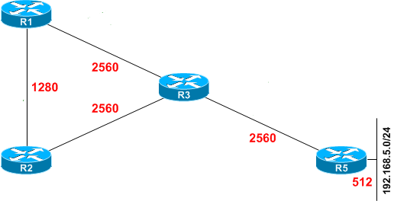

**Figure No. 1**

1. Refer to Figure no. 1, what is the successor and feasible successor for the network 192.168.5.0/24 from Router R1? Justify your answer. [4 marks]
2. What is the purpose of the following commands, [2 marks]

Router(config) router eigrp 100

Router(config-router)# **maximum-paths** **6**

1. Refer to Figure no. 2 & Figure no. 3 below, commands for authentication for router R2 is given. Which parameters or values need to be the same when authentication is also configured for router R1? [3 marks]

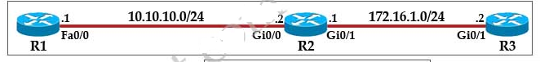

**Figure No. 2**

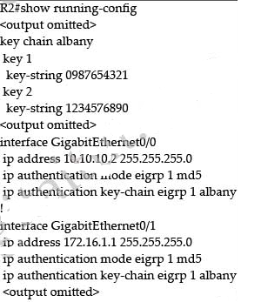

**Figure No. 3**

1. In multi area OSPF, all areas are interconnected to each other, true or false. Explain very briefly. [3 marks]
2. Compare between LSA type 3 and LSA type 5. [3 marks]

Question No. 2

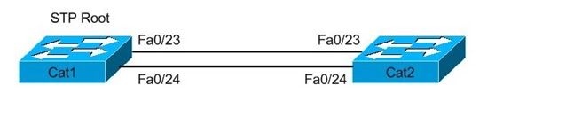

**Figure No. 4**

1. Refer to the above Figure No. 4 above, what does the network administrator need to do if he wishes to make Fa0/23 the root port for Cat2 Switch? [3 marks]
2. State one advantage and one disadvantage of PVST+ over STP. [3 marks]
3. Which states do the ports of a switch go through when running STP? What is the Forwarding Delay of a switch? What about the ports that connect the PCs, do they also go through the same states? [4 marks]

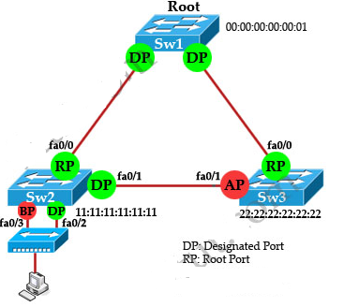

**Figure No. 5**

1. Refer to the above switched network in figure no. 5, which spanning tree protocol is the switches running? The roles “AP” (Sw3, fa0/1) and “BP” (Sw2, fa0/3) implies what? And what states are they in? [5 marks]

**Figure No. 11**

## Question No. 3

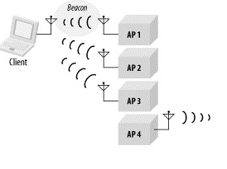

**Figure No. 6**

1. Refer to the Figure no.6, what type of wireless operation is it? What are the next steps for the client to associate with an access point? [4.5 marks]
2. How many addresses are there in a wireless frame? And what are they? [3 marks]

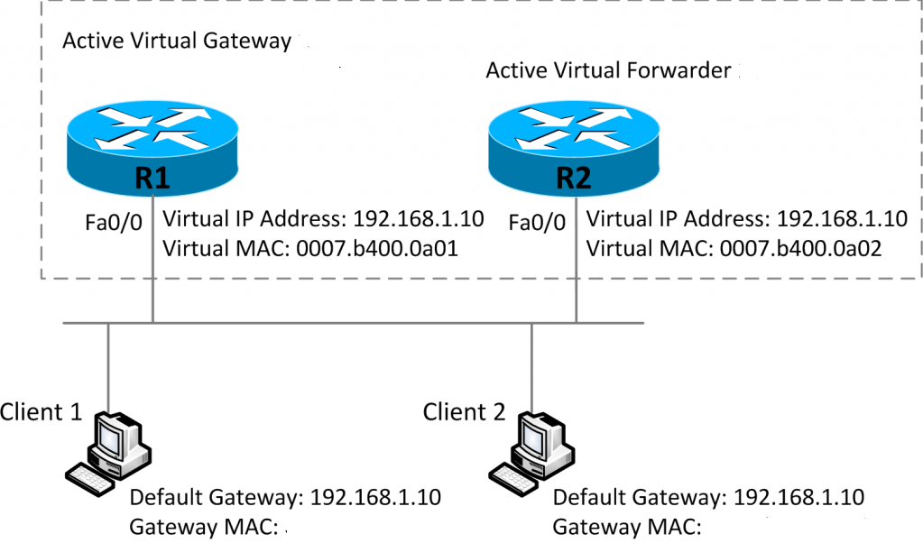

**Figure No. 7**

1. Refer to Figure no.7, what type of redundancy protocol is used here? When Client1 and Client 2 sends an ARP request for the default gateway’s MAC, which router will reply and which MAC addresses will the Router reply to Client1 and Client2 as default gateway’s MAC address? [4.5 marks]
2. How does the Standby router know that the Active router is down? Which value do we change to make a router act as Standby or as Active? [3 marks]

##### THE END